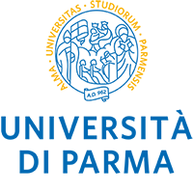

9th EAAE PhD WORKSHOP
Parma, 2022 June 22-24

Extended abstract
(Contributed paper: minimum 1,500 words; maximum 2,000 words)

Title

Introduction

Data and research methodology

Discussion of results

Main conclusions

Essential references

